KENYATTA UNIVERSITY



SCHOOL OF PURE AND APPLIED SCIENCES
COMPUTING & INFORMATION SCIENCE DEPARTMENT

SCO400: PROJECT: CHAPTER 4 & 5

CHAPTER FOUR: SYSTEM ANALYSIS AND REQUIREMENT MODELING

4.1 INTRODUCTION
This chapter provides a comprehensive analysis of the Sanaa platform, an integrated digital marketplace and social ecosystem designed specifically for Kenyan and African artists. The primary goal of this analysis is to evaluate the existing manual and fragmented methods of art trade, identify systemic inefficiencies, and formalize the requirements for a robust digital solution.
Through this phase, the researcher established the organizational context, performed fact-finding through artist surveys, and conducted a feasibility study to ensure the proposed system is viable from technical, economic, and operational perspectives.

4.2 STRUCTURE OF THE ORGANISATION
The Sanaa platform operates as a multi-vendor marketplace involving four primary stakeholder groups. The hierarchy is designed to ensure platform integrity while providing artists with autonomy over their storefronts.
- System Administrator: Responsible for platform moderation, dispute resolution, managing the commission-based revenue model (5-10% per transaction), maintaining the technical infrastructure, logistics coordination for distant deliveries and payment processing oversight.
- Artist (Vendor): The primary content creator. They manage digital portfolios, set pricing, engage with followers via social features, and fulfill orders.
- Buyer (Customer): Users who browse, interact with (like/comment), purchase artwork through the integrated checkout system and contact artists directly or through messaging system.
- Logistics Partners: Third-party courier services integrated or coordinated by the platform to facilitate the physical movement of artwork from artist to buyer.

Figure 2.1: Organizational Structure Diagram
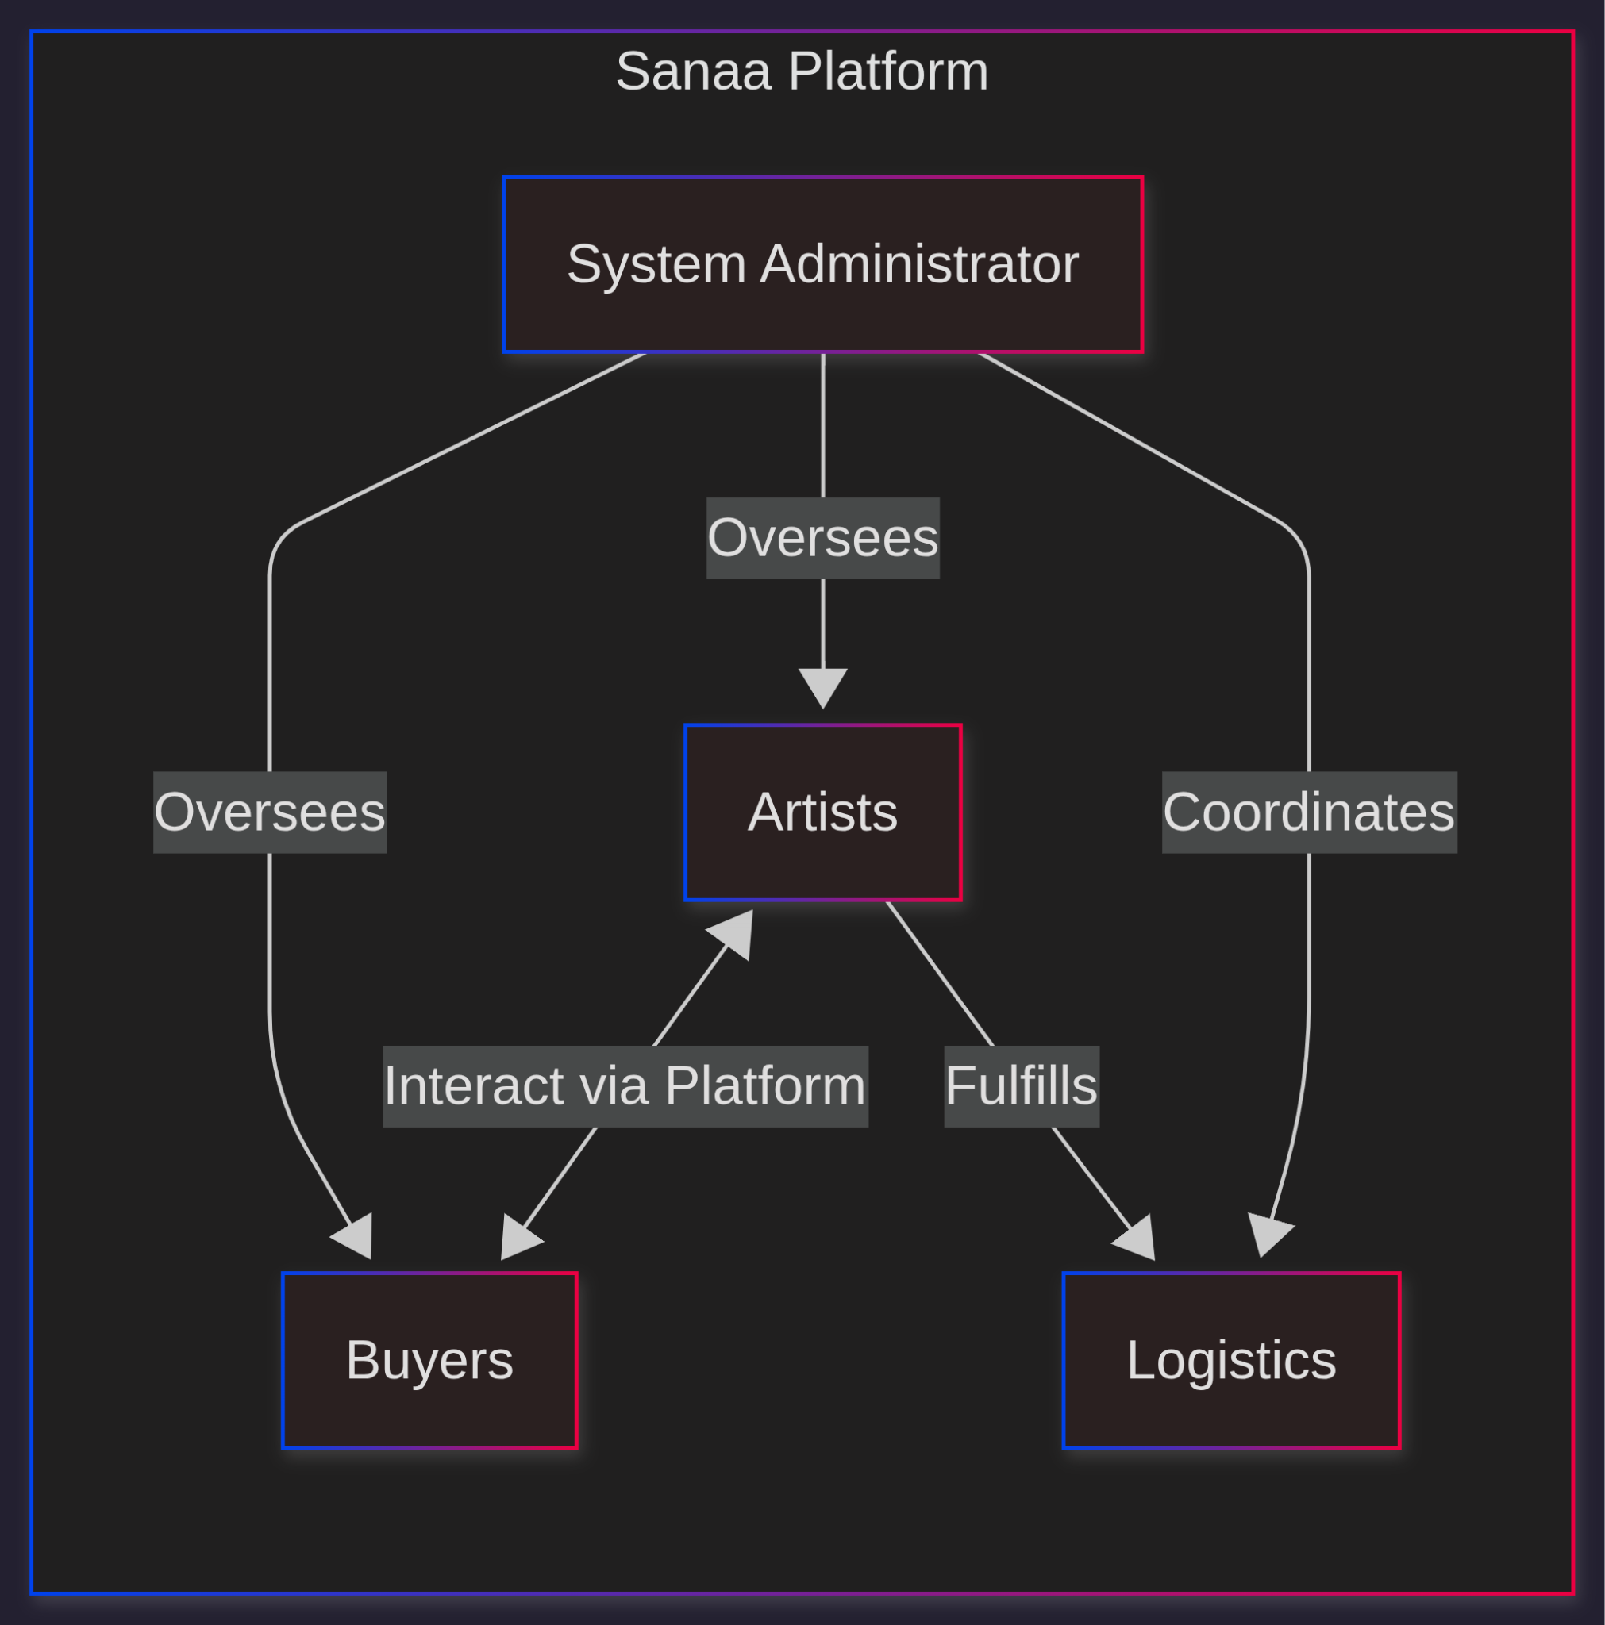

4.3 ANALYSIS OF THE CURRENT SYSTEM
Currently, Kenyan artists operate within a fragmented ecosystem. There is no singular platform that combines e-commerce specialized for art with the social engagement required to build "artist-brand" trust. Artists primarily rely on general-purpose social media (Instagram, WhatsApp) and physical galleries.
The current workflow involves: (1) Artists photograph artwork manually, (2) Post to multiple social media platforms individually, (3) Respond to inquiries through WhatsApp messages, (4) Negotiate prices in private, untracked conversations, (5) Share M-Pesa numbers for direct payment (no transaction security), (6) Arrange delivery through personal contacts or unverified couriers, (7) No data collection on views, engagement, or conversion rates.

4.3.1 Problems of the Current System
- High Brokerage Fees: Traditional galleries in Kenya charge between 40% to 50% commission, making original art unaffordable for the middle class and reducing artist profits.
- Limited Market Access: Respondent "Art maniac 79" noted: "Reaching out to many art collectors who know the value of art is so challenging." Sanaa Platform would solve this by bringing together lovers of art in one space.
- The "Trust Gap": Buyers hesitate on upfront payments; artists face commitments falling through. JABER JOHN DIANG'A: "when you make a deal with a client then he/she disappoints by not buying the art." im.isaac.k: "Trust issues with the client."
- Marketing Reach and Visibility Challenges: Low organic reach on social media. Clemo.arts_gallery: "No sales is the challenge." im.isaac.k: "Marketing; Low market."
- Logistical Friction: Arranging delivery is currently an ad-hoc process involving unverified third-party riders, leading to risks of damage or theft.
- Information Asymmetry: Artists lack data-driven insights. They cannot see "view-to-purchase" conversion rates or geographic interest in their work.
- Fragmented Platform Management: Maintaining multiple platforms is hectic and creates overhead.

Figure 4.2: Current System Data Flow Diagram
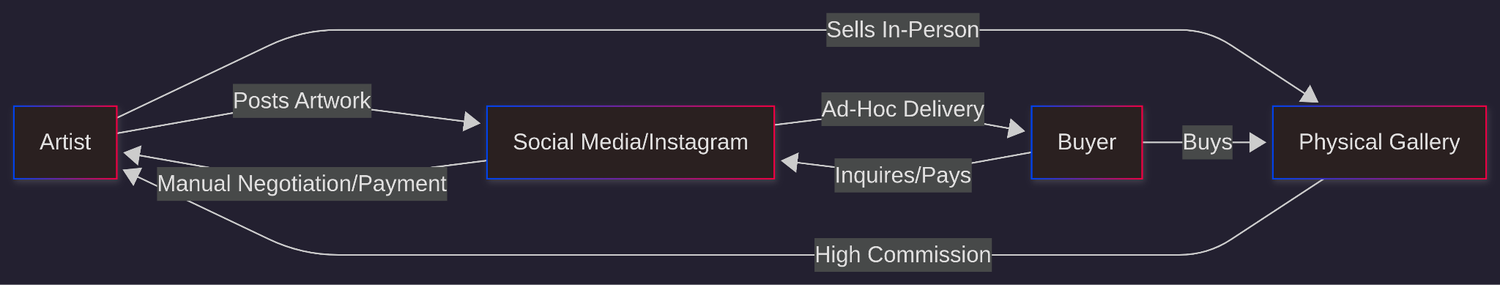

4.4 FACT FINDING REPORT
The researcher conducted a requirement gathering exercise using observation, interviews and digital questionnaires distributed to local artists.

4.4.1 Method 1: Observation
Observation: Through direct engagement with the Kenyan art scene, the researcher noted fragmentation: Artists sell via physical shops and noisy social media, where algorithms bury art amid unrelated content. Collectors are limited to known artists/shops, missing discoveries, while artists lack exposure. Goal: A dedicated art platform to eliminate noise and foster direct connections.

4.4.2 Method 2: Questionnaire
Online questionnaire ( https://forms.gle/gAVfuMgnWfx6Zqvc8 ). Respondents: Hawaadi, Art maniac 79, JABER JOHN DIANG'A, Clemo.arts_gallery, im.isaac.k.
Key Findings:
- Challenges (Q3): Reaching collectors, deal disappointments, low market, trust issues.
- Art Support (Q4): 60% any with clear categories; 40% only original.
- Features (Q5): 100% easy upload; 80% artist profile; others varied.
- Contact (Q6): 80% direct; 20% mix.
- Analytics (Q7): 60% views/clicks vs. purchases; 40% profile views/sales tracking.
- Payments (Q8): 100% M-Pesa (online/on delivery).
- Commission (Q9-10): 100% yes if 5-15%.
- Logistics (Q11): 100% yes for distant at cost.
- Other Features (Q12): Reels, comments, global connections, security.
- Comments (Q13): Positive sentiment.

4.4.3 Method 3: Document Analysis
To inform Sanaa's development, the researcher analyzed existing online art platforms and industry reports, focusing on Saatchi Art and Artsy.
Saatchi Art, a leading gallery with over 1.8 million monthly visits, enables artists to sell originals and prints with features like profiles, high-resolution uploads, and global logistics, but charges a 40% commission on originals (artists retain 60%) and 40% of print profits after costs, alongside limited social tools (no messaging or reels) and no M-Pesa integration, favoring international payments like cards and PayPal; making it less accessible for Kenyan artists facing high fees and local buyer exclusion.
Artsy targets galleries with subscription plans (e.g., Premiere at $900/month + 3% fee) and tools like virtual rooms and AI recommendations, but its high-end focus, 10% sales commission plus buyer's premiums, and lack of direct artist support or social features marginalize emerging African creators; it also omits M-Pesa, emphasizing wire transfers.
The Hiscox Online Art Trade Report 2023 notes $10.8 billion in 2022 online sales (up 6%), stressing trust via secure transactions, while M-Pesa reports highlight its 33 billion 2024 transactions worth KES 40 trillion (rising to KES 83.7 trillion in 2025), essential for Kenya's e-commerce yet absent in these platforms; revealing a gap for an art-specific, low-commission (5-10%), M-Pesa-integrated site like Sanaa.

4.5 FEASIBILITY STUDY

4.5.1 Economic Feasibility
The project is highly feasible. Development utilizes open-source stacks (Django/React), eliminating licensing fees. Initial hosting costs are estimated at approximately KES 15,000–20,000 per year. With art pieces often retailing above KES 5,000, a 5% commission model ensures the platform reaches a break-even point with minimal monthly transactions.

4.5.2 Technical Feasibility
The stack (React, Django, PostgreSQL) is robust and well-supported. The integration of the Safaricom Daraja API for M-Pesa is technically documented and achievable. The researcher possesses the requisite skills in Python and TypeScript to implement the proposed architecture.

4.5.3 Operational Feasibility
The system mimics the UI/UX patterns of Instagram and TikTok (reels/feeds), ensuring that the learning curve for artists and buyers is minimal. Operationally, it solves the "trust" issue by acting as an escrow-like intermediary.

4.6 THE PROPOSED SYSTEM

4.6.1 Requirements Specifications
a. User Requirements:
- Artists: Upload artworks/reels, view analytics, manage profiles.
- Buyers: Browse/search, pay via M-Pesa, track orders.
- Users: Customize profiles, view dashboards.
- Artists: Monthly reports.
b. Business Requirements:
- 5-10% commission deduction.
- Transaction records for 3 years.
- Revenue optimization (promotions).
- Reports for auditing.
c. Functional Requirements:
- M-Pesa processing.
- Uploads with thumbnails.
- Real-time notifications.
- Messaging.
- Social features (posts, reels).
- Analytics.
- Cart/checkout.
- Reviews.
d. Non-Functional Requirements:
- Security: JWT, encryption.
- Performance: <3s loads.
- Responsiveness: Mobile-first.
- Scalability: Horizontal.
- Reliability: 99.5% uptime.
- Usability: Intuitive.
- Maintainability: Code standards.

4.7 DATA FLOW DIAGRAMS

4.7.1 Proposed System Context Diagram (Level 0 DFD)
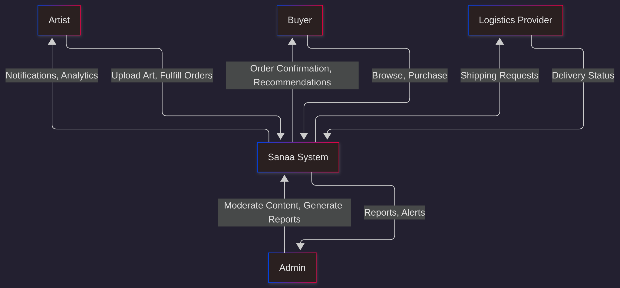

4.7.2 Proposed System Context Diagram (Level 1 DFD)
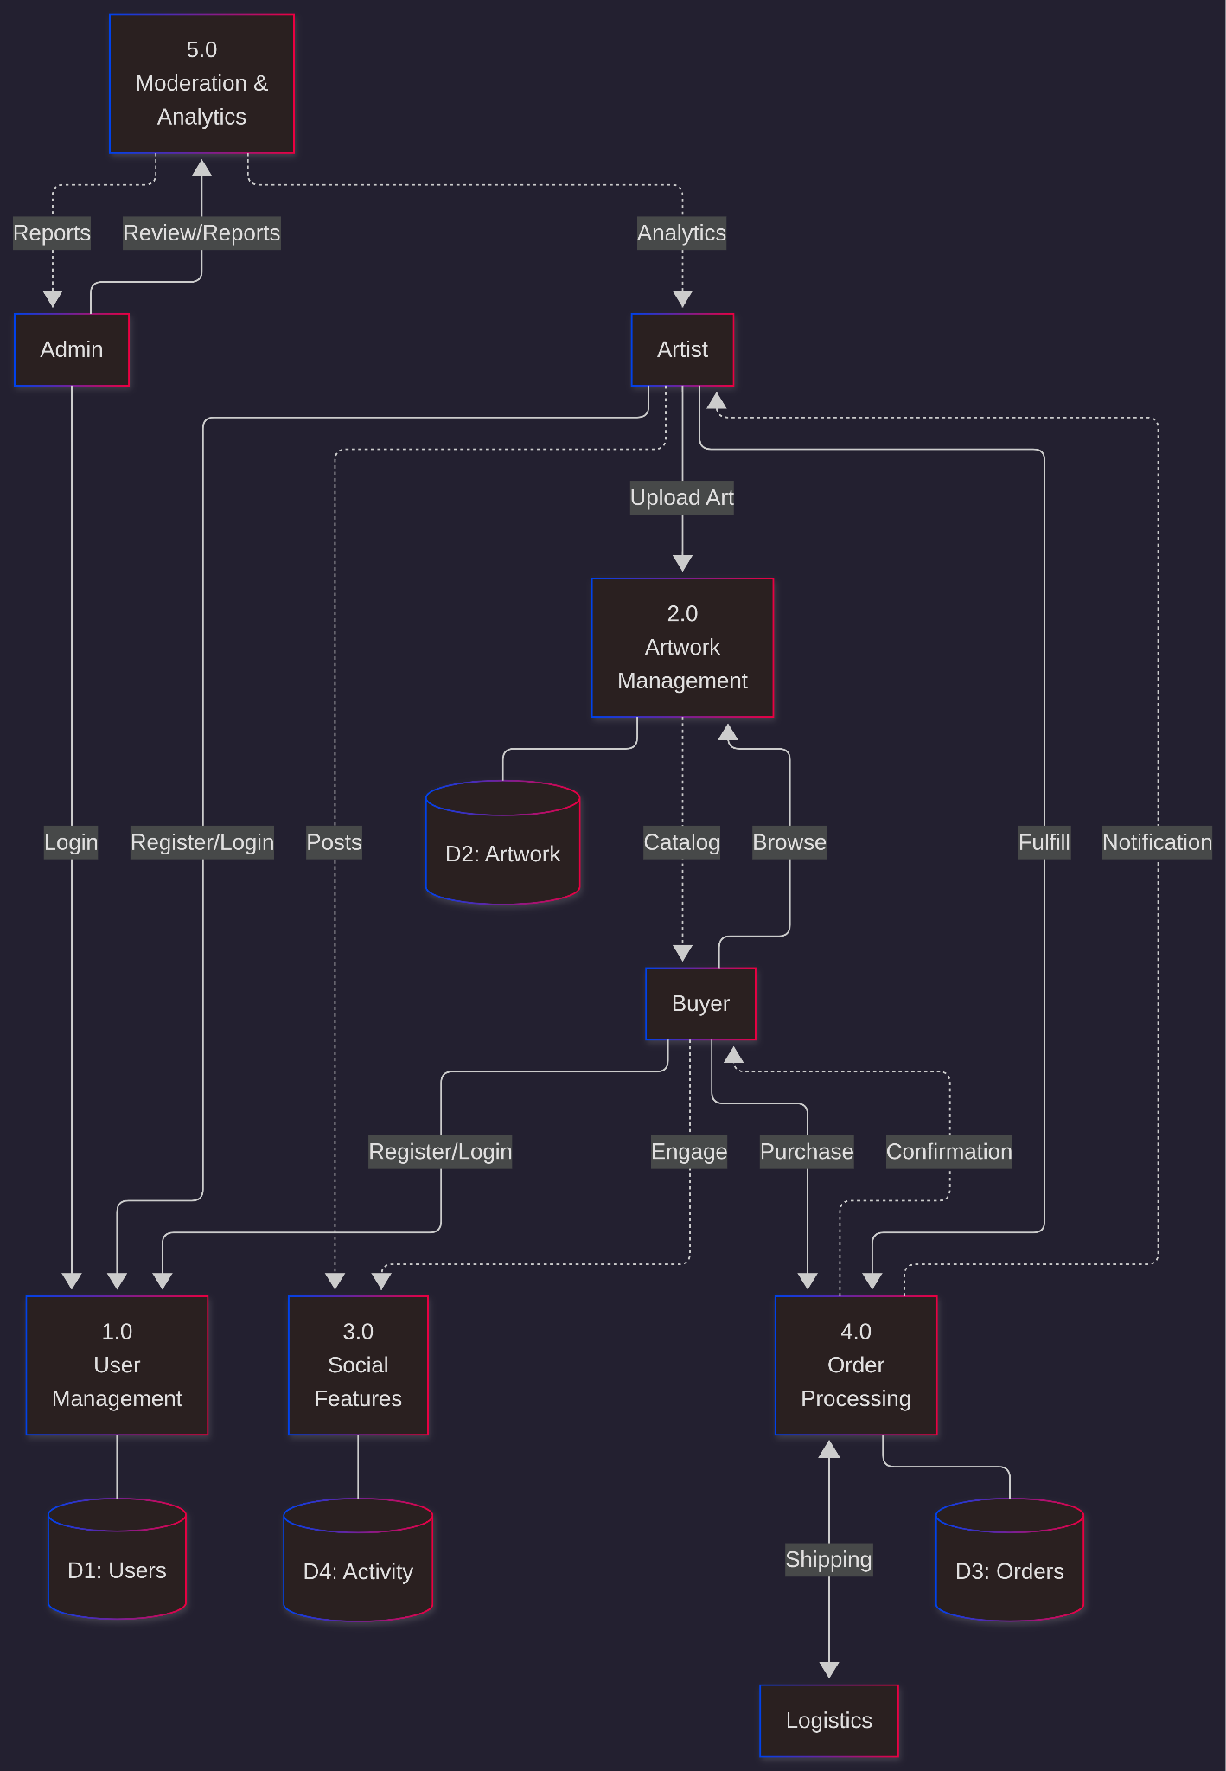

4.7.2 Proposed System Context Diagram (Level 2 DFD)
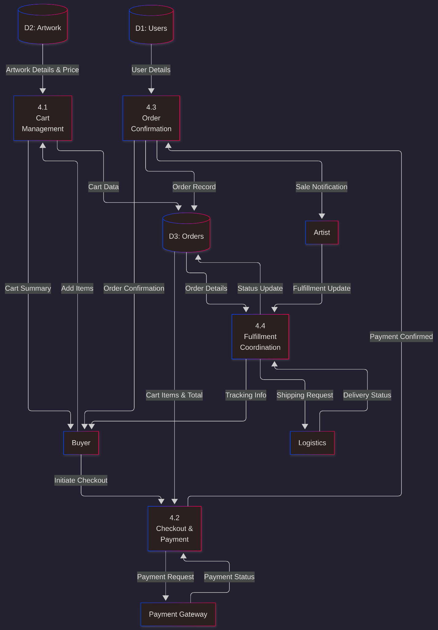

4.7.4 Proposed System Use Case Diagram
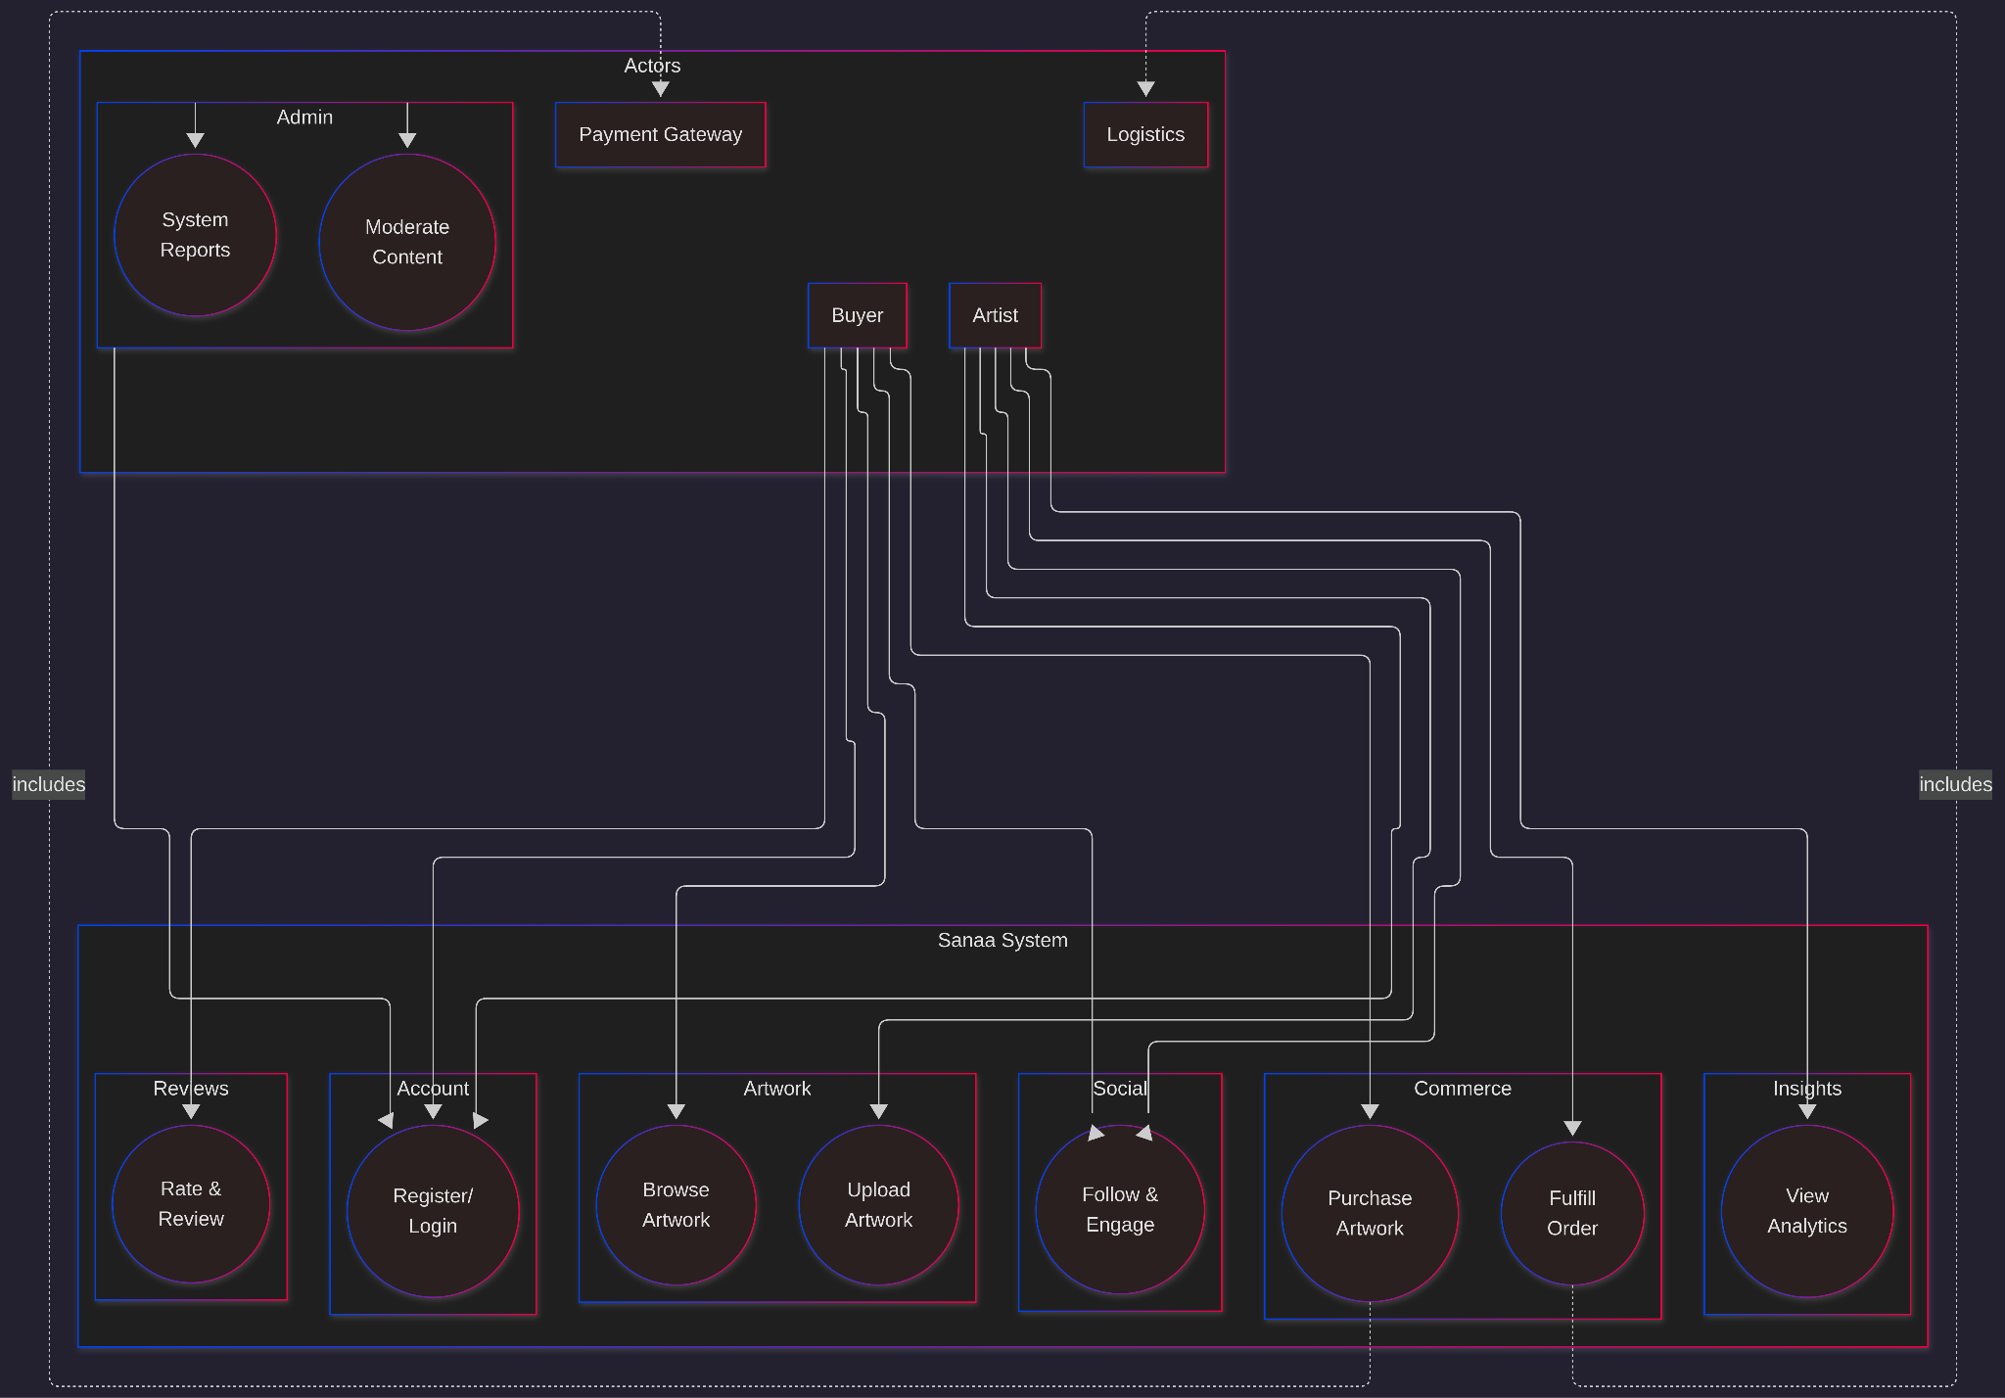

CHAPTER FIVE: SYSTEM DESIGN

5.1 INTRODUCTION
This chapter outlines the technical design of Sanaa, transforming requirements into architectural components, processes, database structures, and UI elements. The design prioritizes usability, security, and scalability for a seamless art marketplace experience.

5.2 ARCHITECTURE OF THE PROPOSED SYSTEM
The system adopts a Decoupled Client-Server Architecture (Headless).
- Frontend (React.js): A Single Page Application (SPA) that handles the user experience. It consumes data from the backend via RESTful APIs.
- Backend (Django REST Framework): Serves as the logic engine. It handles authentication, M-Pesa callback processing, and image metadata management.
- Database (PostgreSQL): A relational database chosen for its ability to handle complex relationships between users, artworks, and orders.
- External Services: M-Pesa API for payments, cloudinary for image storage.

Figure 5.1
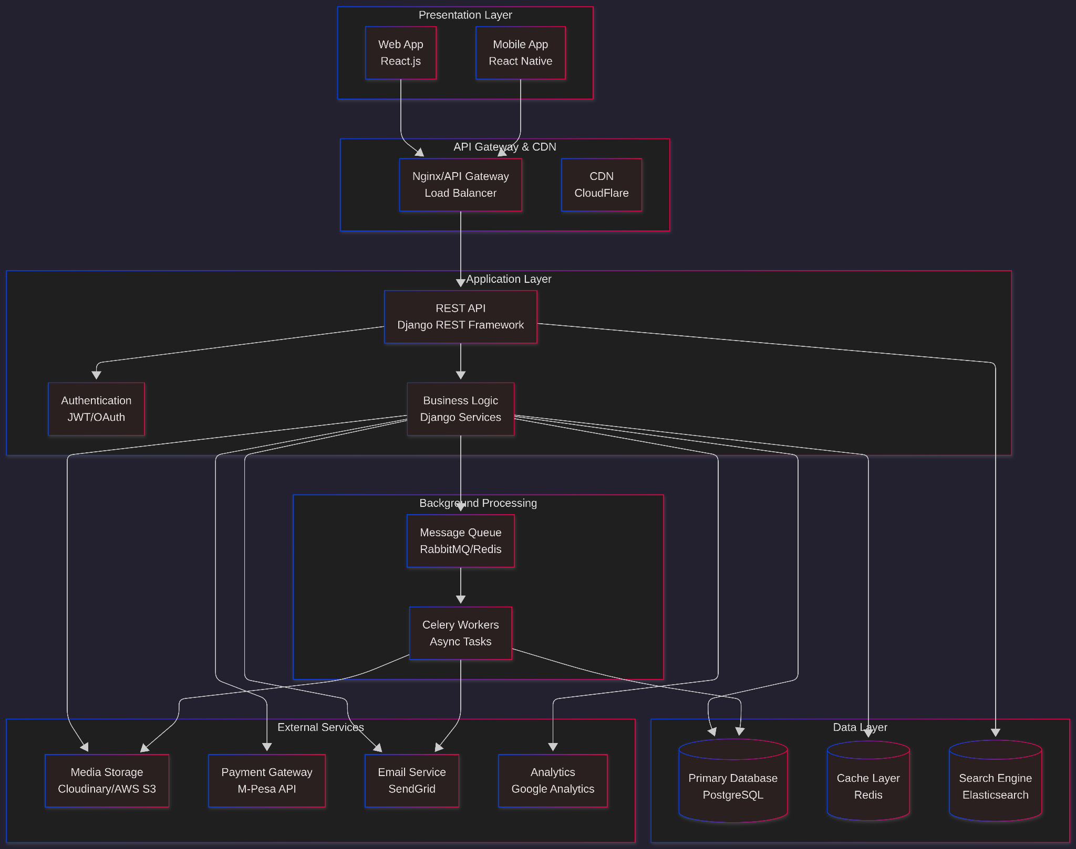

5.3 SYSTEM PROCESS MODELLING

5.3.1 User Registration and Authentication Process

Sequence: User submits form → Frontend validates → POST to backend → Backend hashes password, generates JWT → Returns tokens.

Figure 5.2: Authentication Sequence Diagram
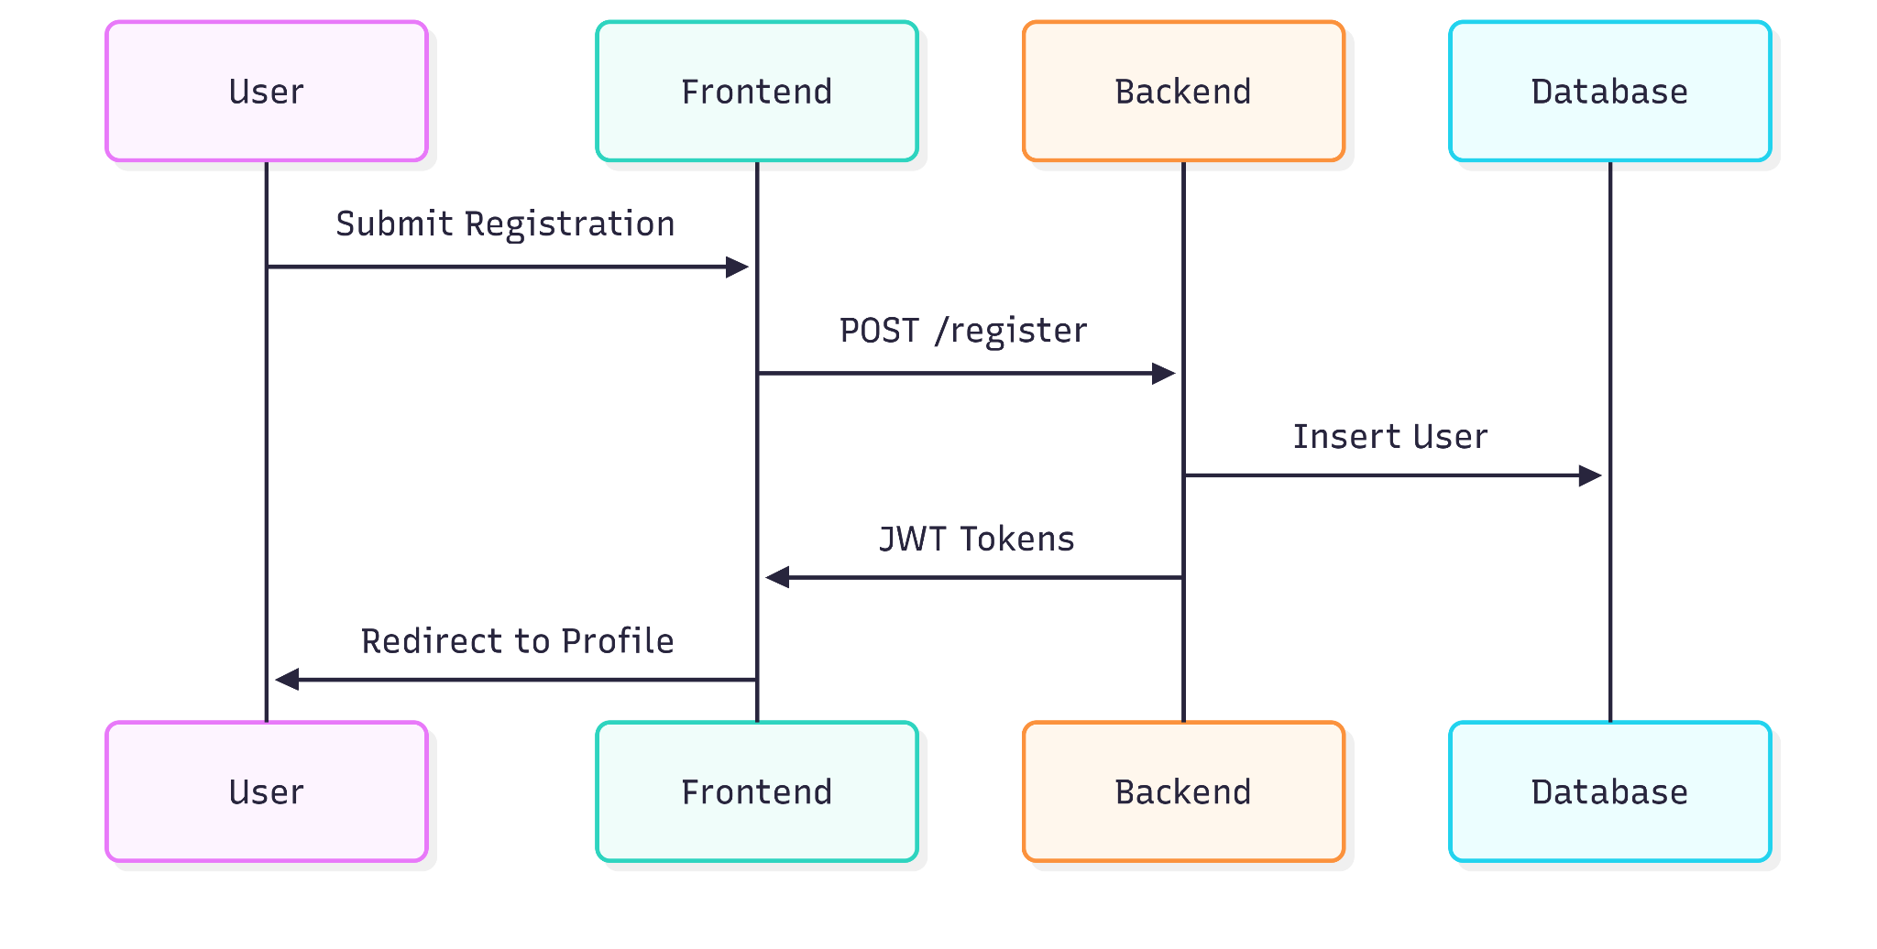

5.3.2 Artwork Upload Process

Artist selects file → Frontend validates → POST to backend → Backend uploads to Cloudinary → Creates record → Queues thumbnails.

5.3.3 Purchase and M-Pesa Process

Buyer adds to cart → Checkout → Backend initiates STK Push → Callback validation → Update status → Notifications.

Figure 5.3: M-Pesa Checkout Flowchart
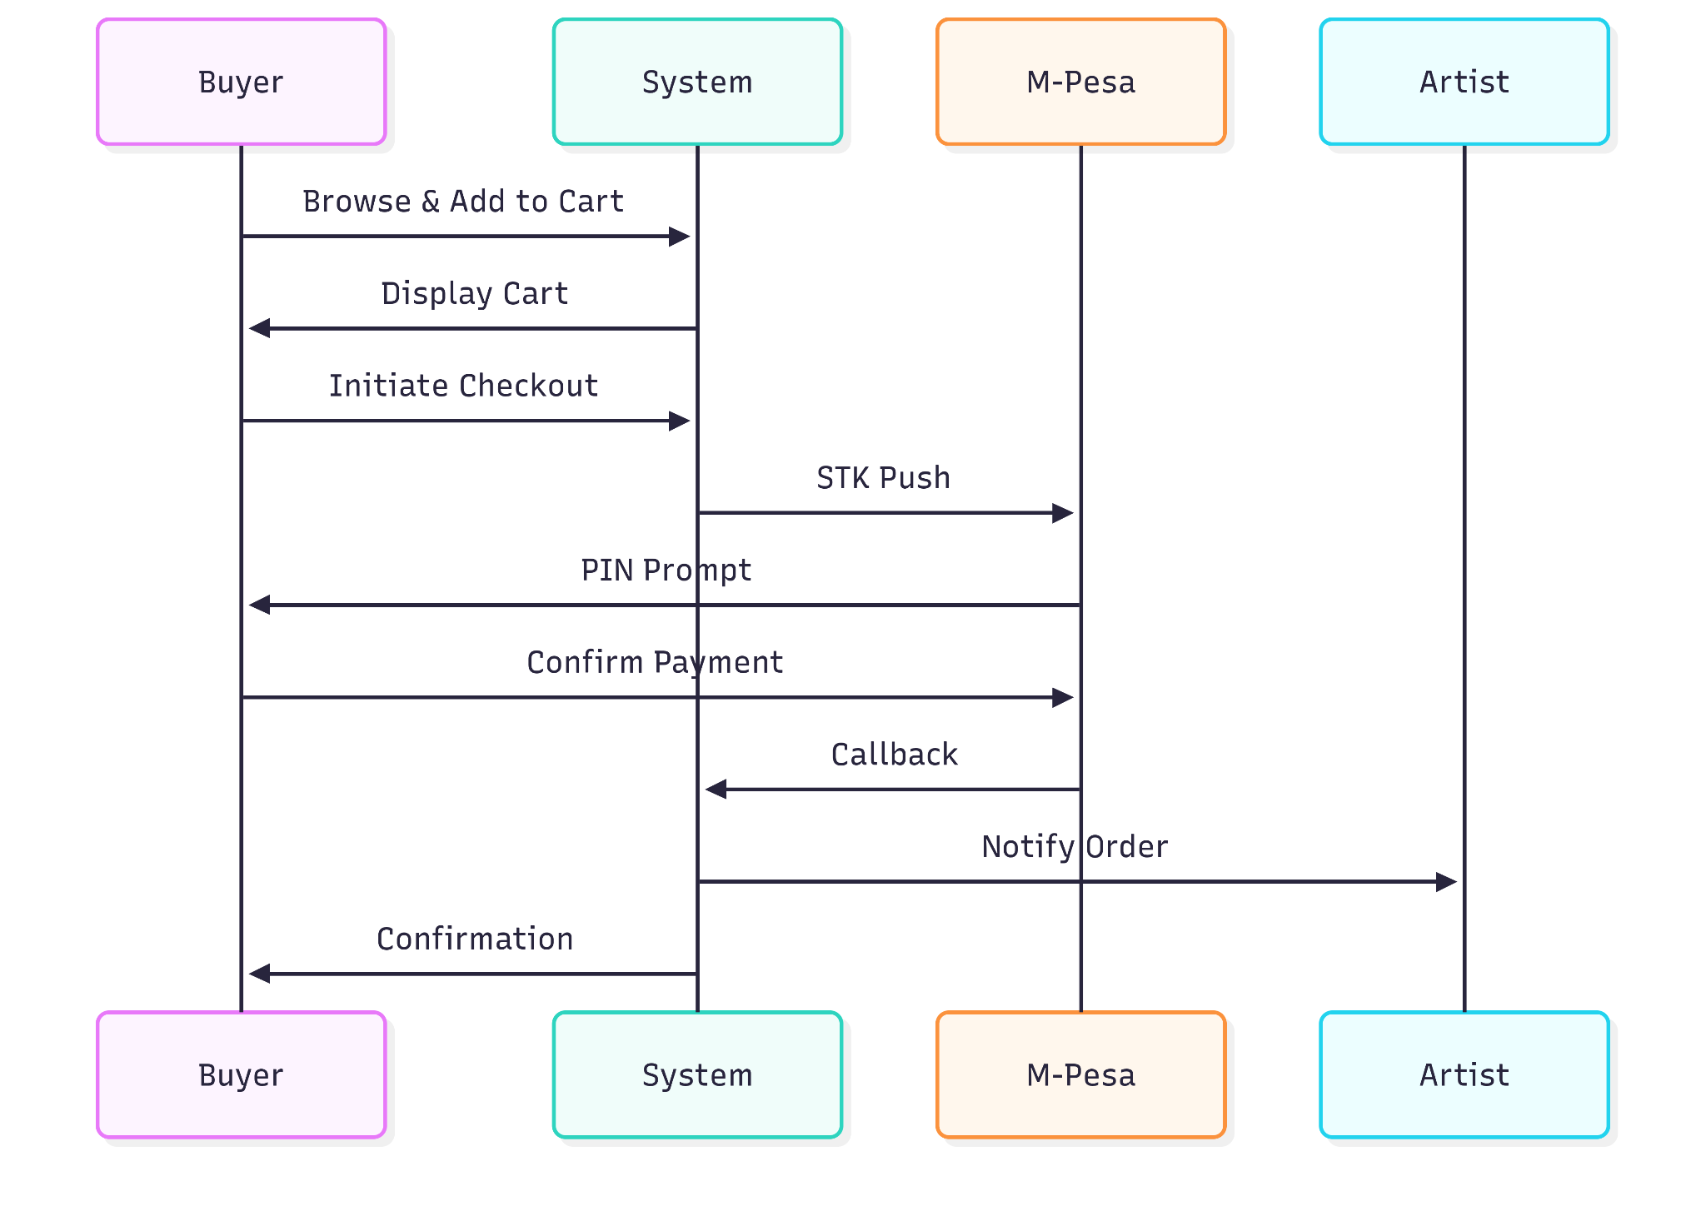

5.4 DATABASE DESIGN
The database is designed following 3rd Normal Form (3NF) principles to ensure data integrity, minimize redundancy, and maintain consistency across the system.

5.4.1 Data Dictionary (Core Tables)
Table: User

Field | Data Type | Constraint | Description
id | UUID | Primary Key | Unique user identifier
username | VARCHAR(50) | Unique, Not Null | User's display name
email | VARCHAR(100) | Unique, Not Null | User's email address
password_hash | VARCHAR(255) | Not Null | Encrypted password
user_type | ENUM('artist', 'buyer', 'admin') | Not Null | Role-based access control
phone_number | VARCHAR(15) | Unique | Contact number for M-Pesa
profile_image | TEXT | Nullable | URL to profile photo
bio | TEXT | Nullable | User biography/description
created_at | TIMESTAMP | Default NOW() | Account creation date
updated_at | TIMESTAMP | Default NOW() | Last profile update
is_active | BOOLEAN | Default TRUE | Account status
Table: Artwork
Field | Data Type | Constraint | Description
id | UUID | Primary Key | Unique artwork identifier
artist_id | UUID | Foreign Key (Users.id) | Reference to artist
title | VARCHAR(200) | Not Null | Artwork title
description | TEXT | Not Null | Artwork description
price | DECIMAL(10,2) | Not Null, CHECK(price > 0) | Price in KES
category | ENUM('painting', 'sculpture', 'digital', 'photography', 'mixed_media') | Not Null | Art category
stock_qty | INTEGER | Default 1, CHECK(stock_qty >= 0) | Available quantity
image_url | TEXT | Not Null | Primary image URL
dimensions | VARCHAR(50) | Nullable | Size (e.g., "24x36 inches")
medium | VARCHAR(100) | Nullable | Materials used
upload_date | TIMESTAMP | Default NOW() | Date uploaded
status | ENUM('draft', 'published', 'sold', 'archived') | Default 'draft' | Artwork status
Table: Orders
Field | Data Type | Constraint | Description
id | UUID | Primary Key | Unique order identifier
buyer_id | UUID | Foreign Key (Users.id) | Reference to buyer
order_number | VARCHAR(20) | Unique, Not Null | Human-readable order ID
total_amount | DECIMAL(10,2) | Not Null | Total order value (KES)
commission_fee | DECIMAL(10,2) | Not Null | Platform fee (5-10%)
artist_payout | DECIMAL(10,2) | Not Null | Amount paid to artist
status | ENUM('pending', 'paid', 'processing', 'shipped', 'delivered', 'cancelled') | Default 'pending' | Order status
payment_method | VARCHAR(50) | Default 'M-Pesa' | Payment gateway used
shipping_address | TEXT | Not Null | Delivery address
created_at | TIMESTAMP | Default NOW() | Order creation time
updated_at | TIMESTAMP | Default NOW() | Last status update

5.4.2 Entity Relationships
- Users (1) → Artworks (N): One artist uploads many artworks
- Users (1) → Orders (N): One buyer places many orders
- Orders (1) → Order_Items (N): One order contains many items
- Orders (1) → Transactions (1): Each order has one payment transaction
- Artworks (1) → Reviews (N): One artwork receives many reviews
- Users (N) ↔ Users (N): Many-to-many follows relationship
- Artworks (1) → Analytics (N): Daily analytics per artwork

5.5 USER INTERFACE (UI) DESIGN
The UI design focuses on "Visual Hierarchy," ensuring the artwork is the focal point.
- Artist Dashboard: A clean interface showing a grid of their portfolio and a "Sales Analytics" card displaying views vs. sales.
- Navigation: Top bar (search, notifications); Bottom tabs on mobile (Browse, Social, Upload, Messages, Profile).
- Upload Interface: Drag-drop, form fields (title, description, price).
- Marketplace: Masonry grid, filters.
- Checkout: 3 steps (Cart, Shipping, Payment) with M-Pesa prompt.
- Notifications/Messages: List of interactions (e.g., orders, likes).
- Social Feed: A vertical scroll experience for "Reels" (process videos) and a masonry grid for the "Marketplace."
- Feedback Loops: Use of "Toast" notifications to confirm successful uploads or payment processing.

Figure 5.7: Site Map
